Localization Support in Essential Diagram

Localization is the key feature for providing solutions to global customers. This is true for a desktop application and even for the Syncfusion Components. Resources are important for localizing an application. These resources hold the settings for different languages and cultures.
Here we are talking about jargons namely Localization, Resources and Cultures. Let’s discuss some points on these.
- Internationalization: It’s nothing but ensuring that an application can handle resources (e.g. strings) in a language-specific fashion. It is also called as (i18n).

- Localization: Also called as l10n, is the process of customizing an application for specific cultures or regions. It’s the adaptation of language, content and design to reflect local cultural sensitivities.

Cultures are of three types. They are discussed below.
Invariant: Invariant Culture is always Culture-insensitive and is primarily used as a “default” culture. You can specify the invariant culture by name, by using an empty string (""). It is associated with the English language but, not with any country/region.

Neutral: A neutral culture is a culture that is associated with a language but, not with a country/region.

Specific: A specific culture is a culture that is associated with a language and a country/region (e.g. “fr-CA” and “fr-FR”). For example, "fr" is a neutral culture and "fr-FR" is a specific culture. Note that "zh-CHS" (Simplified Chinese) and "zh-CHT" (Traditional Chinese) are neutral cultures.

Steps to Localize Syncfusion Components
Syncfusion components have their own Neutral resources and these resources can be localized as per the localization need of the customer. Now let us see the steps for localizing the Syncfusion Diagram control

- The Neutral resources of every Syncfusion Component is present in the “Localization” folder of each of these components source code. For the Diagram control, the resource is present in the path given below. Assume that “C:\Program Files\” is the installation path for the Syncfusion components.

- Inside the NeutralResources folder, there are four resource files that are corresponding to the Diagram control of Syncfusion Products. These resources contain the string representation of the English (Default & Neutral) culture.

- Microsoft Visual Studio.NET ships with a tool called the Resource Editor (ResEditor) which, can be used to localize the string resources. It provides a graphical interface that allows you to construct resources files containing bitmaps, icons, and strings.

- The ResEditor tool source code can be found in the VS.NET 2003 location that is given below.
\\SDK\v1.1\Samples\Tutorials\resourcesandlocalization\reseditor\

- Compile the source code using the “build.bat” command in the Microsoft Visual Studio 2003 Command prompt. The left most figure shows how the ResEditor tool looks when it is first open.

- Using ResEditor open, the resource file named “Syncfusion.Windows.Forms.Diagram.SR.resources” that is present in the NeutralResources folder. The image in the right shows all the string resources that are displayed in the tool.

- Now the actual step for localization begins. After opening the resource file in the ResEditor tool, start entering the equivalent strings for the required culture. For this example German language will be used..
In the image of ResEditor that is shown below, all the English strings are replaced by their German equivalent. For instance the German equivalent of Cancel is “Löschen”.

- Open the Visual Studio.NET 2003 Command Prompt and enter WinRes to open the Windows
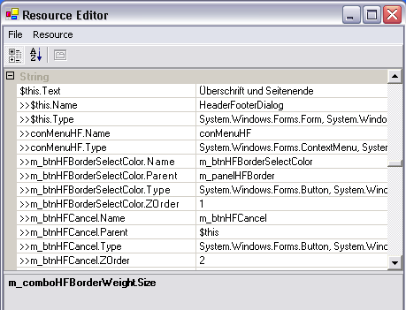
Resource Localization Editor. WinRes is used to work with the Windows Forms resources. The ResEdit tool can’t be used to edit Windows Forms resources but, it can be used to work with images and string based resources only.

- Open the other resources that are using the WinRes utility and replace the English strings with the German equivalent. The following figure shows the file “Syncfusion.Windows.Forms.Diagram.HeaderFooterDialog.resources” that is opened in the WinRes tool and which has German texts. The German texts have been added to the form by using the Properties window.

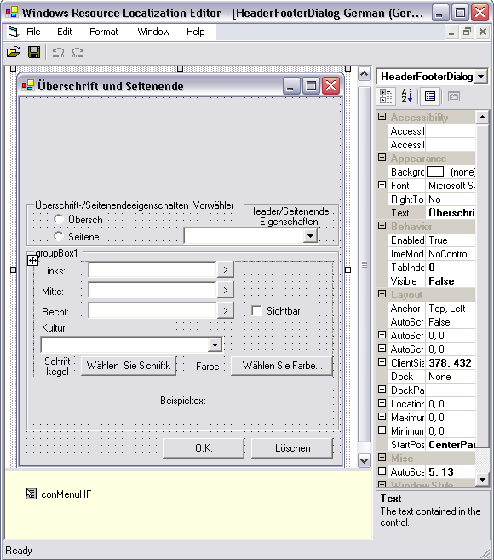

- Click File --> Save As.. and Select the Culture to be localized. ( in this case German- German). Now a new resource file with the name “Syncfusion.Windows.Forms.Diagram.HeaderFooterDialod.de-DE.resources” will be added to the source path.

- Similarly repeat the process for other resources and save it.
Now in the Visual Studio.NET 2003 Command Prompt, type the following command and press enter. Please make sure that you have the sf.publicsnk file from the Localization folder.

al /t:lib /culture:de-DE /out:Syncfusion.Diagram.Windows.resources.dll /v:2.0.0.0 /delay+ /keyf:sf.publicsnk /embed:Syncfusion.Windows.Forms.Diagram.HeaderFooterDialog.de-DE.resources /embed:Syncfusion.Windows.Forms.Diagram.PageBorderDialog.de-DE.resources /embed:Syncfusion.Windows.Forms.Diagram.Controls.PaletteAddDlg.de-DE.resources /embed:Syncfusion.Windows.Forms.Diagram.PrintSetupDialog.de-DE.resources

- The version that you specify for these DLLs in the above “al” command should be based on the SatelliteContractVersionAttribute setting in the product AssemblyInfo. This also means that when a new version of the product is released (with a newer assembly version), you will have to recreate (adding new resources, if any and if necessary) and recompile your resource DLLs with a new version (if the SatelliteContractVersionAttribute has changed).

- On the successful execution, an Assembly file named Syncfusion.Diagram.Windows.resources.dll will be created.

- Finally, mark this satellite DLL for verification skipping (since it’s not signed with the same strong-name as the product assembly), as follows:
sn –Vr Syncfusion.Diagram.Windows.resources.dll

- Now drop this DLL into an appropriate sub-dir under your EXE’s directory (bin\Debug\), based on the naming conventions that are enforced in .NET. You should put it in the “de-DE” sub-directory if this DLL contains resources from the German (Germany) culture.
Finally you should specify your application to fetch the German resources during run time. Here is the code for that. To change the UI culture of the current thread, add this code in the Forms constructor before the InitializeComponent().

Thread.CurrentThread.CurrentUICulture = new System.Globalization.CultureInfo("de-DE");

- Now run your application containing the Syncfusion Diagram control and open the Header Footer Dialog.Surprisingly you will see the Dialog in German, as given below.
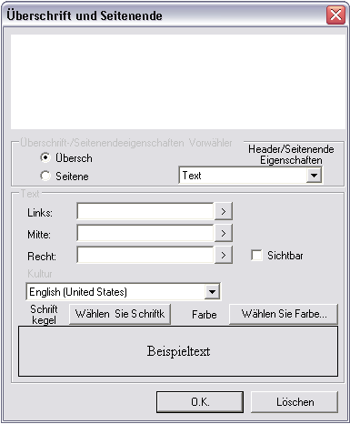

NB:
- The German Translation is done based on some online tools.
- For information regarding Localization and Resources, kindly refer http://msdn.microsoft.com

